# Tambour Twenty

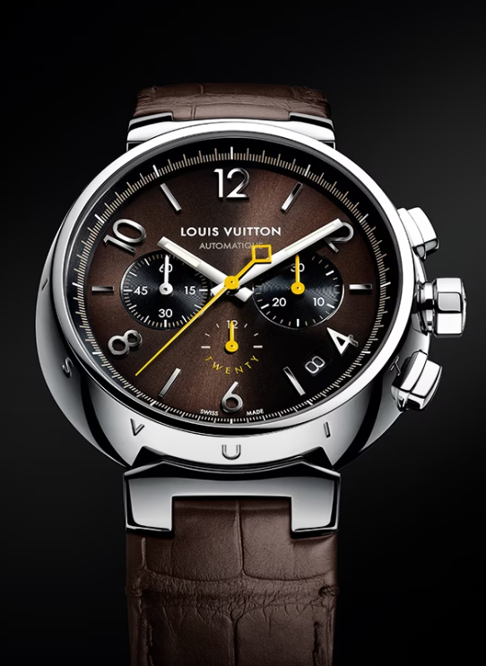

Savoir-faire

Combining bold creativity and exceptional craftsmanship, the Tambour Twenty keeps time with an LV277 high-frequency movement which is based on the iconic Zenith El Primero, the first automatic chronograph ever. This movement with 22-carat gold rotor and 50 hours of power reserve is exact to the tenth of a second.

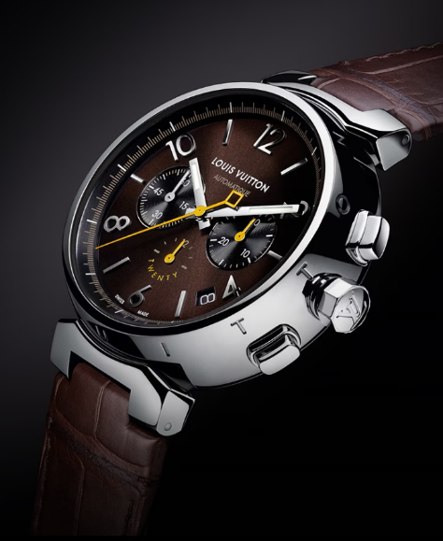

Pushing the Boundaries

Offered in a limited edition of 200 pieces, the timepiece pays tribute to the original Tambour by reprising the signature codes that made it an icon of watchmaking design.